📰 News+AI – Google News Sentiment Dashboard

1. Introduction
The News+AI project is a web-based dashboard built using Streamlit.
It collects real-time news from Google News RSS and analyzes the sentiment (Positive, Negative, Neutral) of news headlines using Natural Language Processing (NLP).
The dashboard helps users understand the public mood about any topic on a particular day.

2. Objective
The main objectives of this project are:
- To fetch real-time news based on a user’s topic
- To analyze the sentiment of news headlines
- To visualize sentiment results using charts
- To compare two topics based on today’s news mood

3. Technologies Used
- Streamlit – To build the web dashboard interface
- Pandas – For data handling and processing
- Feedparser – To fetch Google News RSS feed
- VADER Sentiment Analyzer – For sentiment analysis
- Plotly – For interactive charts (Pie chart & Line chart)
- Matplotlib & WordCloud – To generate word cloud
- Python – Programming language

4. Working of the Project
Step 1: User Input
- User enters a topic (example: Artificial Intelligence)
- Optionally selects another topic for comparison
Step 2: Fetch News
- The app fetches latest news from Google News RSS
- News headlines and published dates are stored in a DataFrame
Step 3: Sentiment Analysis
- Each headline is analyzed using VADER
- Sentiment score is calculated
- Headlines are classified as:
  - 😊 Positive
  - 😟 Negative
  - 😐 Neutral
Step 4: Visualization
The dashboard contains 5 tabs:
- 📊 Overview
  - Shows total Positive, Negative, Neutral news
  - Displays Pie Chart
- 📈 Sentiment Flow
  - Shows sentiment score trend using Line Chart
- ☁️ Trends
  - Displays Word Cloud of most frequent words
- 📰 Headlines
  - Shows news headlines in table format
- 📊 Comparison
  - Compares two topics side-by-side
  - Shows which topic has more positive news

5. Special Features
- 🌙 Dark Mode option
- 🔄 Auto-updates daily
- ⚡ Cached data for faster performance
- 📊 Interactive charts
- 🧠 Simple explanation of comparison results

6. Output
The output is an interactive dashboard that:
- Shows today’s news sentiment
- Helps users understand public opinion
- Visually compares two different topics

7. Conclusion
The News+AI Dashboard is a real-time sentiment analysis system that combines news data and artificial intelligence.
It helps users quickly understand the emotional tone of news about any topic.
This project demonstrates the use of:
- Data Collection
- NLP (Sentiment Analysis)
- Data Visualization
- Web App Development

CODE

import streamlit as st
import pandas as pd
import feedparser
import urllib.parse
from vaderSentiment.vaderSentiment import SentimentIntensityAnalyzer
from wordcloud import WordCloud
import matplotlib.pyplot as plt
import plotly.express as px
from datetime import date

# ====================== SESSION STATE INIT ======================
if "dark_mode" not in st.session_state:
st.session_state.dark_mode = False

# ====================== PAGE CONFIG ======================
st.set_page_config(
page_title="Google News Sentiment Dashboard",
page_icon="📰",
layout="wide"
)

# ====================== SIDEBAR ======================
with st.sidebar:
st.header("⚙️ Settings")
st.session_state.dark_mode = st.toggle("🌙 Dark Mode", st.session_state.dark_mode)
st.caption("🔄 Auto-updates daily")

# ====================== DARK MODE ======================
if st.session_state.dark_mode:
st.markdown(
"""
<style>
body, .stApp { background-color:#0e1117 !important; color:#e6e6e6 !important; }
section[data-testid="stSidebar"] { background-color:#161b22 !important; }
h1,h2,h3,h4,h5,h6,p,span,div,label { color:#e6e6e6 !important; }
.stTextInput input { background-color:#262730 !important; color:#ffffff !important; }
thead tr th { background-color:#161b22 !important; color:white !important; }
tbody tr td { color:#e6e6e6 !important; }
</style>
""",
unsafe_allow_html=True
)

# ====================== SENTIMENT ======================
analyzer = SentimentIntensityAnalyzer()

def analyze_sentiment(text):
score = analyzer.polarity_scores(text)["compound"]
if score >= 0.05:
return "Positive", score
elif score <= -0.05:
return "Negative", score
else:
return "Neutral", score

# ====================== FETCH NEWS ======================
@st.cache_data(ttl=300)
def fetch_google_news(query, max_results=30):
encoded_query = urllib.parse.quote(query)
url = f"https://news.google.com/rss/search?q={encoded_query}&hl=en-IN&gl=IN&ceid=IN:en"
feed = feedparser.parse(url)

rows = []
for entry in feed.entries[:max_results]:
published = pd.to_datetime(entry.get("published", None), errors="coerce")
rows.append({
"Headline": entry.title,
"Published": published.date() if pd.notnull(published) else None
})
return pd.DataFrame(rows)

# ====================== HEADER ======================
today = date.today()

st.title("📰 News+AI ")
st.markdown(f"### 📅 News Analysis for **{today.strftime('%d %B %Y')}**")
st.info("ℹ️ Dashboard updates automatically every day.")

# ====================== INPUT ======================
col1, col2 = st.columns(2)

with col1:
topic = st.text_input("🔍 Enter Topic", "Artificial Intelligence")

with col2:
compare = st.checkbox("🔁 Compare with another topic")

topic2 = None
if compare:
topic2 = st.text_input("🔍 Second Topic", "Stock Market")

# ====================== ANALYZE ======================
if st.button("🚀 Analyze Today’s News"):

with st.spinner("Fetching today's news..."):

df = fetch_google_news(topic)

if df.empty:
st.warning("⚠️ No news found.")
st.stop()

df_today = df[df["Published"] == today]
if not df_today.empty:
df = df_today

df[["Sentiment", "Score"]] = df["Headline"].apply(
lambda x: pd.Series(analyze_sentiment(x))
)

tab1, tab2, tab3, tab4, tab5 = st.tabs(
["📊 Overview", "📈 Sentiment Flow", "☁️ Trends", "📰 Headlines", "📊 Comparison"]
)

# ====================== TAB 1 ======================
with tab1:
c1, c2, c3 = st.columns(3)
c1.metric("😊 Positive", (df["Sentiment"] == "Positive").sum())
c2.metric("😟 Negative", (df["Sentiment"] == "Negative").sum())
c3.metric("😐 Neutral", (df["Sentiment"] == "Neutral").sum())

fig = px.pie(
df,
names="Sentiment",
color="Sentiment",
color_discrete_map={
"Positive": "#2ecc71",
"Negative": "#e74c3c",
"Neutral": "#f1c40f"
}
)
st.plotly_chart(fig, use_container_width=True)

# ====================== TAB 2 ======================
with tab2:
fig_line = px.line(
df.reset_index(),
x=df.reset_index().index,
y="Score",
color="Sentiment"
)
st.plotly_chart(fig_line, use_container_width=True)

# ====================== TAB 3 ======================
with tab3:
text = " ".join(df["Headline"])
wc = WordCloud(width=800, height=400, background_color="white").generate(text)

plt.figure(figsize=(10, 5))
plt.imshow(wc, interpolation="bilinear")
plt.axis("off")
st.pyplot(plt)

# ====================== TAB 4 ======================
with tab4:
st.dataframe(
df[["Published", "Headline", "Sentiment", "Score"]],
use_container_width=True
)

# ====================== TAB 5 ======================
with tab5:

if not compare:
st.subheader("📊 Topic Comparison – Today’s Public Mood")
st.caption(
"Side-by-side comparison to clearly see which topic has more positive or negative news today 👇"
)

else:
df2 = fetch_google_news(topic2)
df2 = df2[df2["Published"] == today]

if df2.empty:
st.warning(f"⚠️ No news today for **{topic2}**.")
else:
df2[["Sentiment", "Score"]] = df2["Headline"].apply(
lambda x: pd.Series(analyze_sentiment(x))
)

p1 = (df["Sentiment"] == "Positive").sum()
n1 = (df["Sentiment"] == "Negative").sum()
ne1 = (df["Sentiment"] == "Neutral").sum()

p2 = (df2["Sentiment"] == "Positive").sum()
n2 = (df2["Sentiment"] == "Negative").sum()
ne2 = (df2["Sentiment"] == "Neutral").sum()

colA, colB = st.columns(2)

with colA:
st.markdown(f"### 🟦 {topic}")
st.metric("😊 Positive", p1)
st.metric("😟 Negative", n1)
st.metric("😐 Neutral", ne1)

fig1 = px.pie(
names=["Positive", "Negative", "Neutral"],
values=[p1, n1, ne1],
title=f"{topic} – Today’s News Mood",
color_discrete_map={
"Positive": "#2ecc71",
"Negative": "#e74c3c",
"Neutral": "#f1c40f"
}
)
st.plotly_chart(fig1, use_container_width=True)

with colB:
st.markdown(f"### 🟧 {topic2}")
st.metric("😊 Positive", p2)
st.metric("😟 Negative", n2)
st.metric("😐 Neutral", ne2)

fig2 = px.pie(
names=["Positive", "Negative", "Neutral"],
values=[p2, n2, ne2],
title=f"{topic2} – Today’s News Mood",
color_discrete_map={
"Positive": "#2ecc71",
"Negative": "#e74c3c",
"Neutral": "#f1c40f"
}
)
st.plotly_chart(fig2, use_container_width=True)

st.subheader("🧠 What This Means (In Simple Words)")

if p1 > p2:
st.success(
f"📈 **{topic}** has more positive news today compared to **{topic2}**."
)
elif p2 > p1:
st.success(
f"📈 **{topic2}** has more positive news today compared to **{topic}**."
)
else:
st.info(
f"⚖️ Both **{topic}** and **{topic2}** have a similar news mood today."
)

# ====================== FOOTER ======================
st.markdown("---")
st.caption("📌 Real-time Google News • NLP Sentiment • Auto-updating Dashboard")

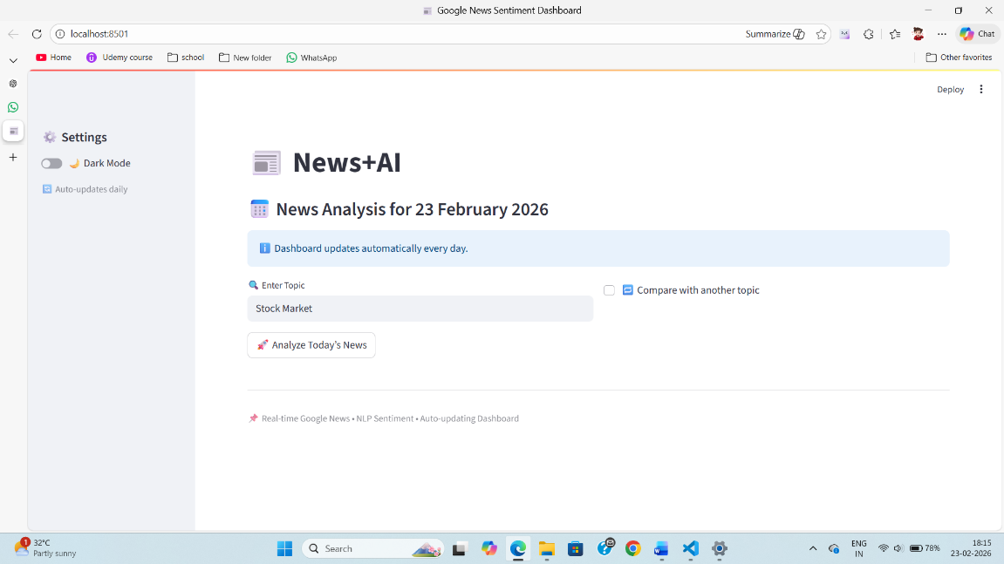
SCREENSHOTS

